Procure-to-Pay Office Hours
December 11, 2025
Summary Notes

Travel
- All request tickets due Dec 15 for end of year processing
- Happy Holidays!

Accounts Payable & Tax Service
- How to view invoices on hold.
- From the PO view (Example: overbilled - UCMP00070505 and COA -UCMP00067411)
- Click on View Details, locate invoice number you are inquiring about, and it will state On Hold next to it
- From the Invoice view (Example: #22755 and #INV11054)
- Starting from the invoice tile, click search then enter the invoice number in Oracle. Click the invoice number to populate the invoice details; Oracle is designed to populate hold reasons under the Hold and Approval tab (review system hold reasons), if you click on the note icon, AP will provide additional information about the hold reasons.
  - Invoices are matched to the PO line by line; we do not match the overall total of the PO.
  - Go over entire invoice line from the PO view details

- Our communication and hold action processes:
- We manage a holds list for actions taken and resolutions. We check the invoice and the PO and email the supplier and requestor (if PO provided) letting them know the invoice is on hold and the reason.
- Invoices are normally overbilled via quantity, unit price, or prices of services rendered. If the invoice is overbilled the department requestor should carefully review the invoice and the corresponding PO to ensure they are being charged correctly, if invoice is deemed correct a change order will be needed and this can be requested through a General Purchasing ticket.
- If the invoice is found to be incorrect, please work with the Supplier to correct the invoice. We provide these instructions on how to correct the issue and how to submit the corrected invoice.
  - Highly encourage departments to be proactive in reviewing their invoices to ensure they are being invoiced correctly; this can be done by comparing the invoice to the PO.

- The invoice resolution ticket – when to use it:
- If requestor has the correct PO number, then they can submit a resolution ticket asking that we remove the hold and process invoice (provide invoice #) to PO (provide PO number) and include the invoice in the ticket.
- If they purchased the items on the invoice with a PCard, then submit a resolution ticket asking to have invoice cancelled as items purchased with PCard and include the PCard receipt in the ticket. (Example: RITM0418988, Paid with Pcard – RITM0407444)

- Per our UC Policy, a PO is required prior to purchasing goods or services.
- Best practices for invoice hold prevention:
- Be sure to tell the supplier to put the PO on the invoice before they submit it for processing.
- Departments with exempt suppliers who receive invoices for preapproval, please make sure the PO number is clearly identiﬁed before invoice submission.
- If purchased with a PCard, please make sure to tell the supplier NOT to send an invoice to Accounts Payable.
- If you decide to add items to your order before the supplier invoices, please submit a change order request to have the goods or services added to the PO.
- If you decide, after a PO has been generated that you want to purchase with a PCard, please submit a request to cancel PO and provide the PCard receipt. (Example: Invoice with red PO number)

Procurement
- BobcatBuy+ New enhancements coming in January
  - 15-20 additional suppliers
  - Updated search results page, now with option to Quick Look and preview the product without leaving the results page
    - 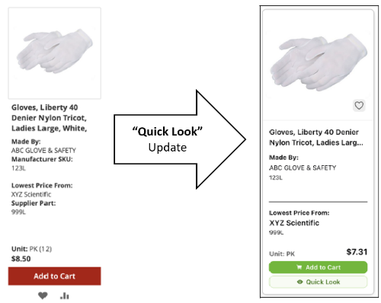
  - Quote parsing tool; ability to upload a PDF/other file quote to BobcatBuy+, the tool will read and e-generate the quote. You would compare to the file to ensure accuracy and then can add the items to your cart.
    - This is in addition to the current ability to navigate to the suppliers direct page within BobcatBuy+ to pull down a quote from their website.

